**Lesson 14: Scientific Notation**

**Do Now:**

100

100000

1000

1000000

10000

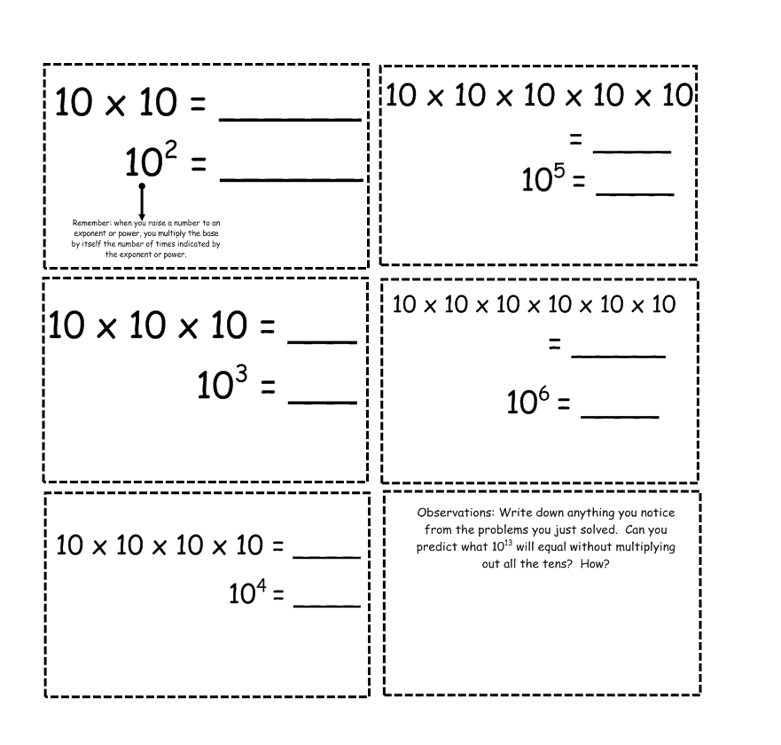

**Independent Practice:**

93,000,000 miles

3,670,050,000 miles

About 5.2

81*1014

81 is bigger than 10. 8.1*1015

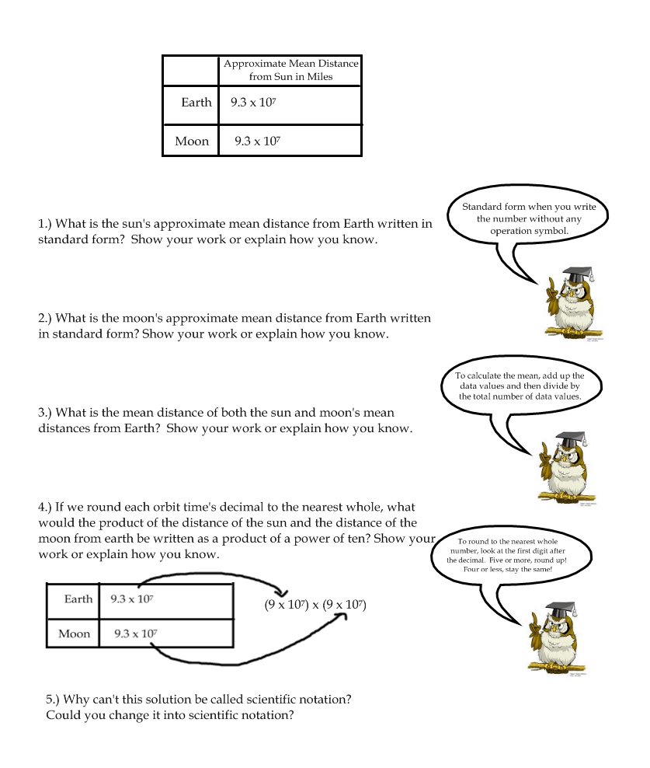

2. NASA recently released images of Pluto. Pluto is 3.67*109 miles away from the Sun. Write this in scientific notation.

3. Jupiter’s approximate mean distance from the Sun is about 4.84*108 miles. Divide that distance by the mean distance of the Earth from the Sun. The answer should be in scientific notation.